公路（高美古路）Small Roads through ‘China’
This road offers the rare advantage of changing scenery. We could try some dialogues on truck cab on platform here, change costumes/hair to do a bunch of different scenes?)
1.公路（高美古路）——路程：30公里，45分钟。1. Highway (Gaomei Ancient Road) — Distance: 30 km, 45 minutes.
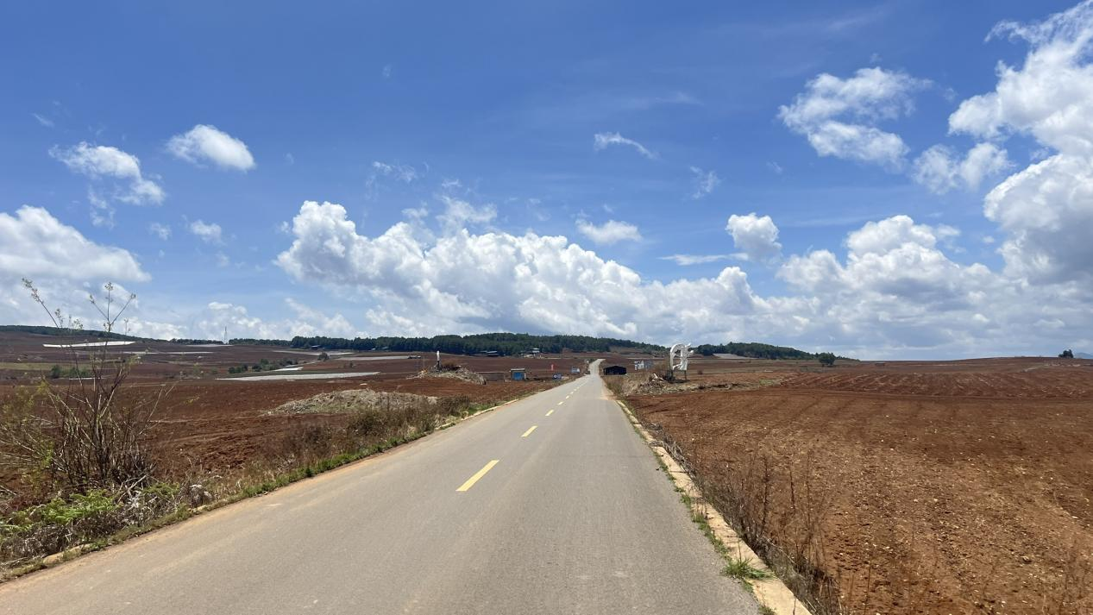
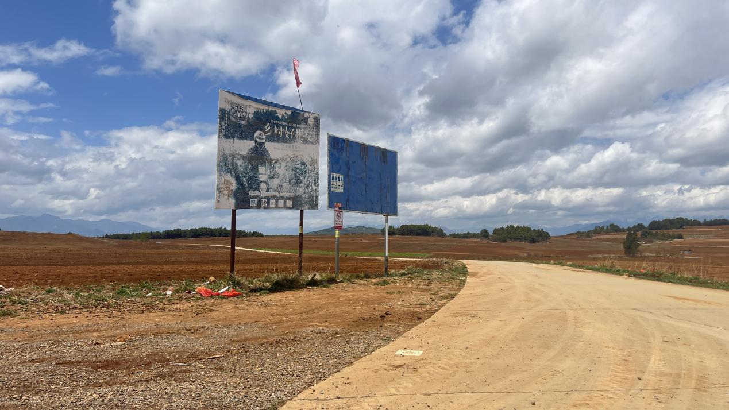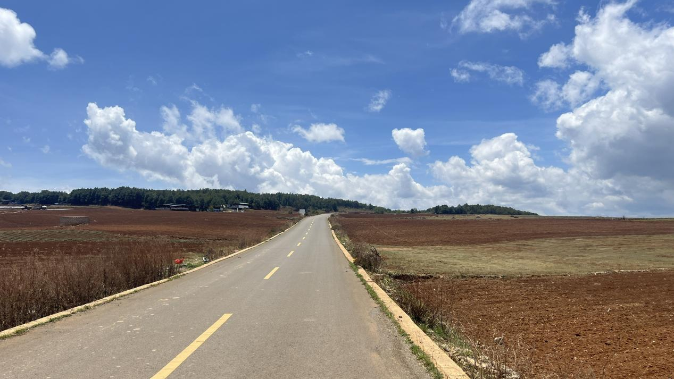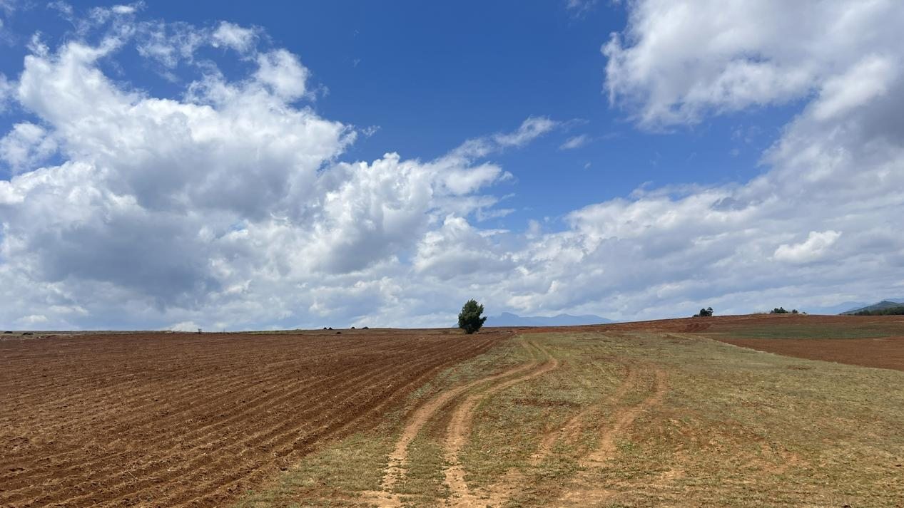
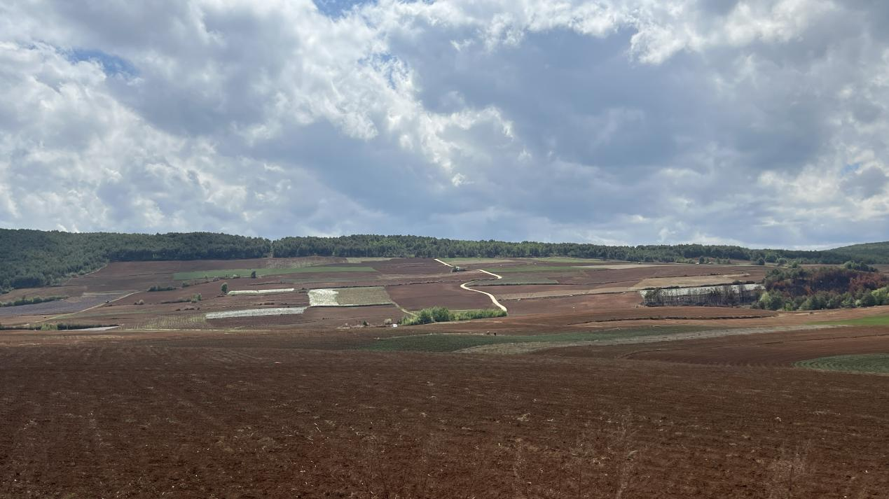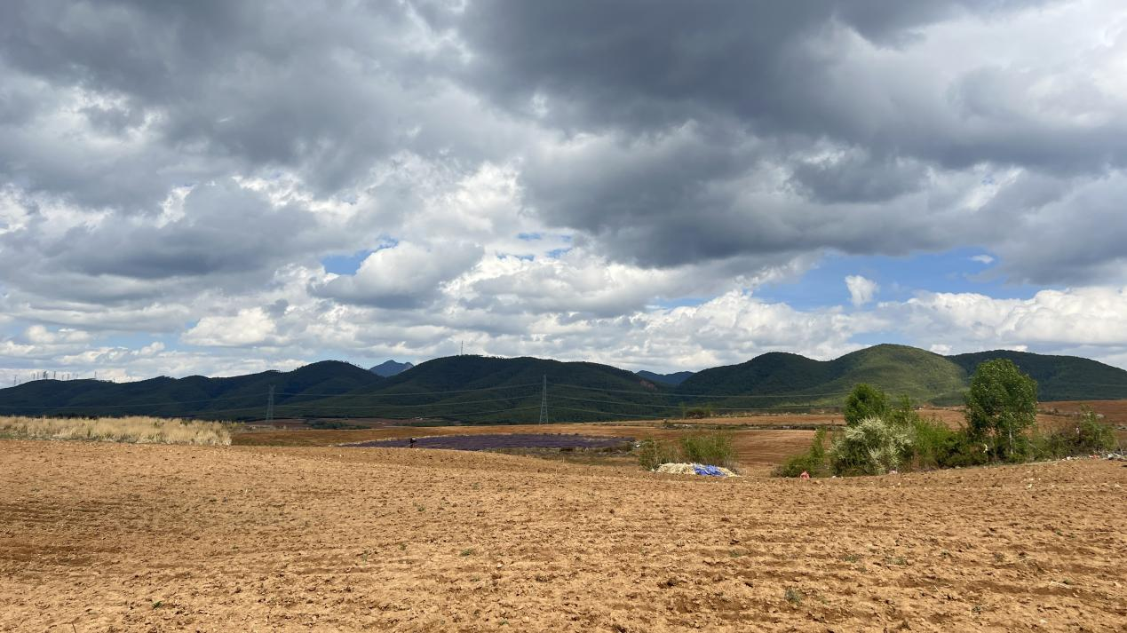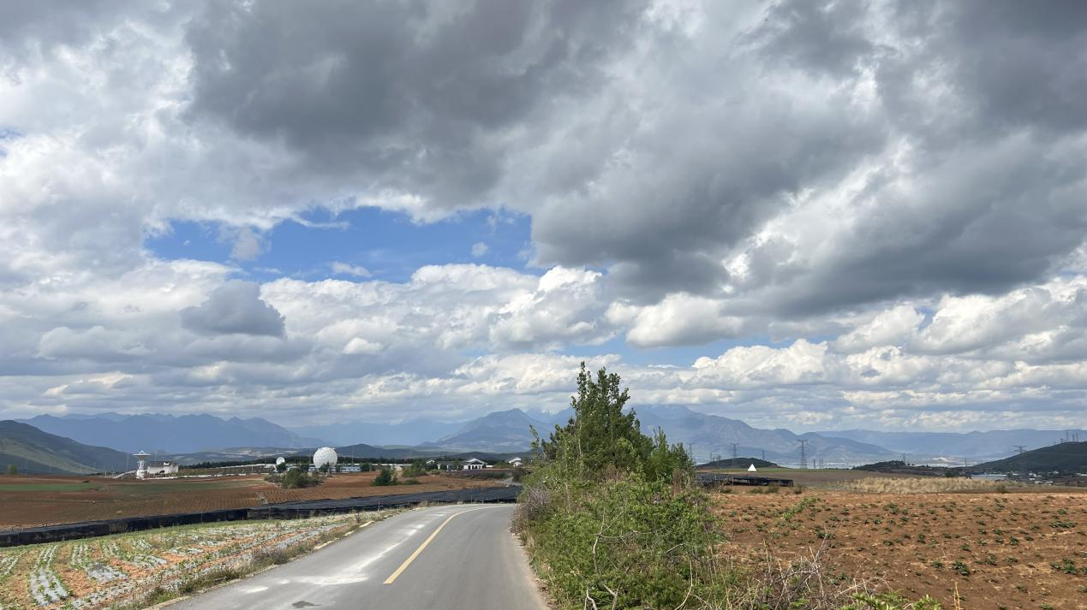

地点：丽江西南

